**SALESFORCE PROJECT**

**MILKEASE**

* **Phase 4 :   Process Automation (Admin)** 👉 Goal **:** Automate tasks.
* **Validation Rules**:-
* Prevent saving Booking date before tomorrow or later .

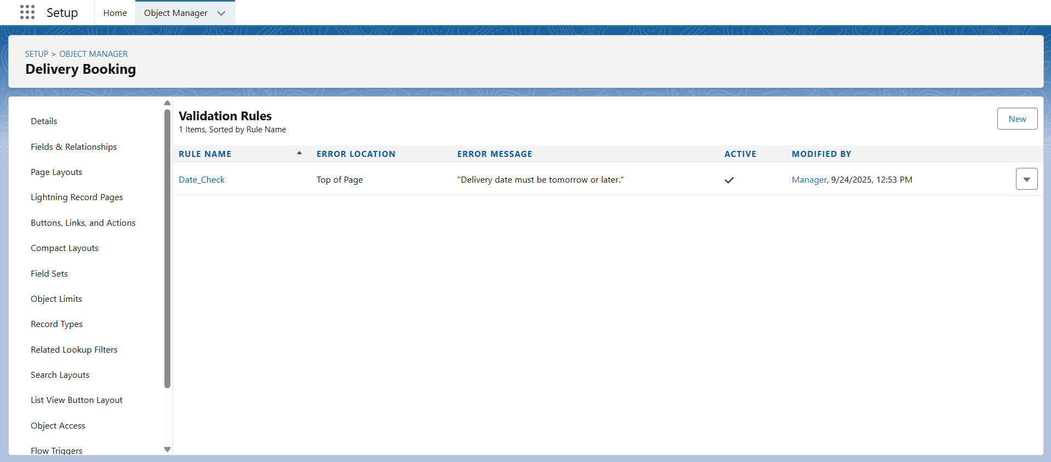

* **Approval Process** :-
* Booking > ₹50,000 → sent for Manager approval.

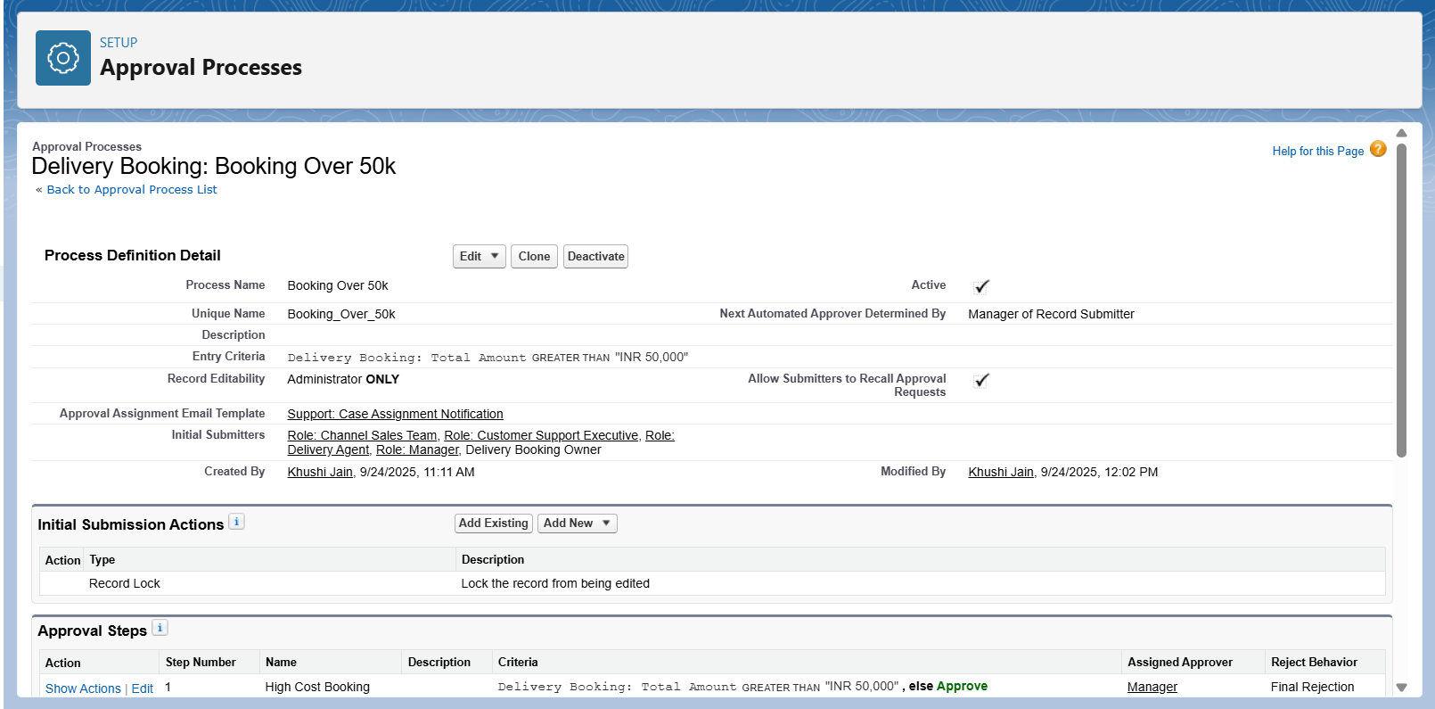

* **Field Updates**:-
* After approval, Approval Status = “Confirmed”

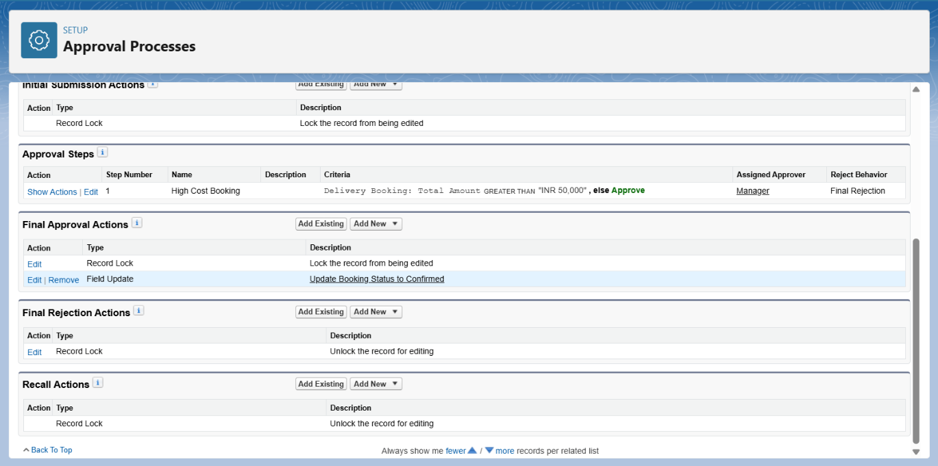

* **Custom Notifications**:-
* Send in-app notification to Agent after approval.

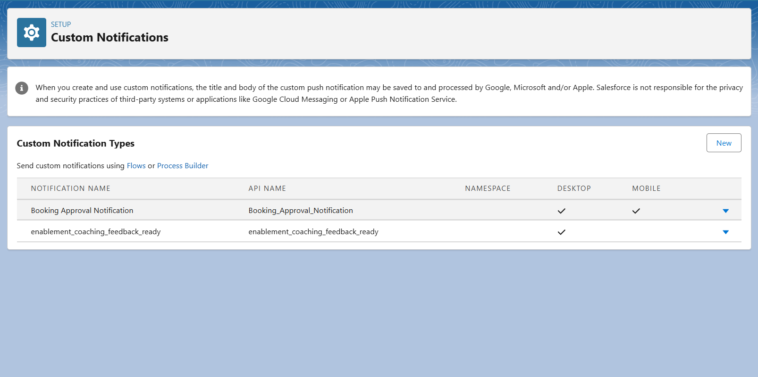

* **Tasks**:-
* Create a task for the Agent to prepare the delivery.

